# Overview

The Chicago Crime data set contains data of crime in the city of Chicago from 2012 to 2017. The Chicago Crime Application consists of one primary dashboard:

1. The Chicago Crime Dashboard consists of crime data broken down by offense, offense details, location, and year. The visuals inform the user on metrics such as: What offenses make up the majority of Chicago crime? How has crime changed over the years? Has it increased/decreased? What Chicago neighborhoods/police beats have the highest incidences of crime? Within these neighborhoods, what offense is most prevalent?

Insights from this application can help Chicago Law Enforcement better understand crime patterns and trends within their respective police beats.

# Chicago Crime Analysis Dashboard

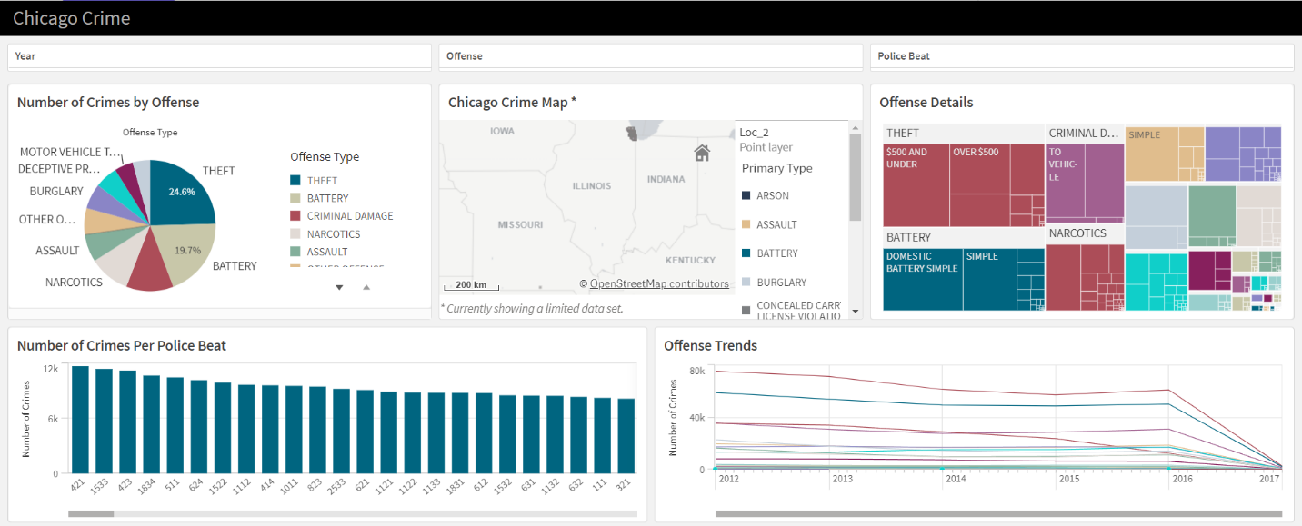

Attached above is an overview of the Chicago Crime Analysis Dashboard. The main features include a crime pie chart broken down by offense, Chicago map, offense detail tree map, number of crimes per police beat bar chart, and a line chart depicting changes in offense occurrences over the years.

The dashboard also contains filters at the top of the dashboard including year, offense, and police beat. The year filter allows for users to filter by a specific year or time frame starting from 2012 through 2017. The offense filter allows for the user to filter by one, multiple, or all offenses such as theft, assault, narcotics, etc. The police beat filter allows for a user to filter by one, multiple, or all police beats in the city of Chicago.

When a user hovers over an offense in the pie chart, a tool tip will appear displaying the offense name and number of occurrences.

When a user clicks on an offense in the pie chart, the surrounding charts and map will change to filter to show data regarding that offense only.

For example, if I click on narcotics, the surrounding charts inform me that the greatest number of narcotic related crimes occur in Police Beat 1533 with a steady decrease in number of offenses from 2012 through 2017. It also informs me that the majority of narcotic crimes were related to Cannabis, Heroine, and Crack. The map filters to show locations where narcotic related crimes occurred. The number of narcotic related crimes by location is displayed through the size of the point with larger points indicating a higher number of narcotic related crimes.

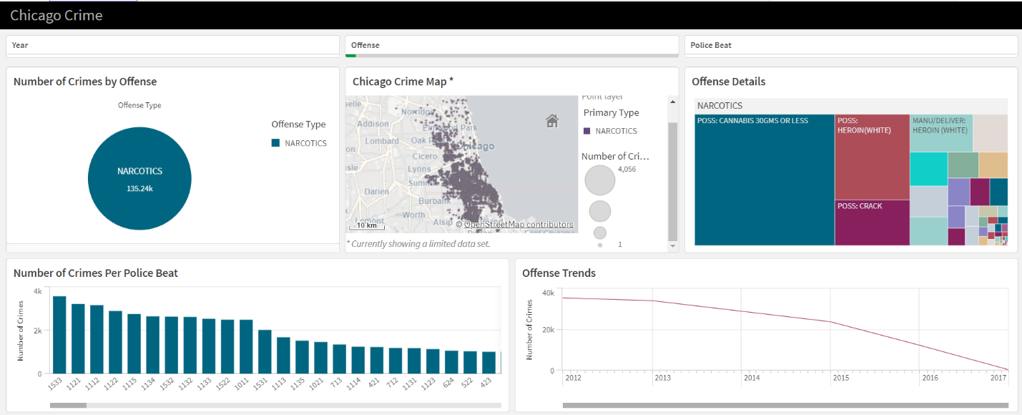

A user can investigate further by filtering by police beat in the filter pane or clicking on the police beat of their choice on the bar graph. For example, when I click on Police Beat 1533 on the bar graph, the map filters to show data related to narcotic crimes within the neighborhoods in that police beat. The offense details tree map updates to show that most narcotic related offenses in this location were related to cannabis and heroine. The number of crimes pie chart updates to show that 3.6k narcotic related offenses occurred within Beat 1533. The offense trend line chart shows an increase in narcotic related crimes within police beat 1533 from 2012 through 2013 before declining. If the user hovers over a point on the map, a tool tip will appear displaying the exact geographical location and number of narcotic offenses at that location.

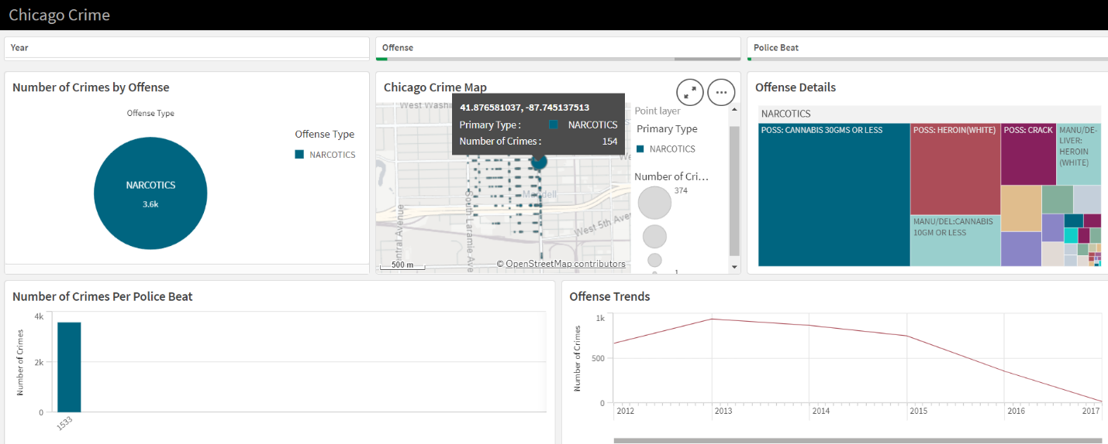

# Conclusion

The Chicago Crime Analysis Application contains one primary dashboard. The Chicago Crime Analysis Dashboard contains crime data with information on offense, offense details, location, and year. The dashboard contains user friendly filters to answer user questions based on offense, year, and police beat. Insights from this application can help Chicago Law Enforcement better understand crime patterns and trends within their respective beat.

Thank you for reading my QLIk analysis!!

Regards,

Julia Farson